PIZZA SALES SQL QUERIES
1.Total Revenue:
select sum(total_price) as total_revenue from pizza_sales;
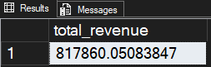
2. Average Order Value:
select sum(total_price)/count(distinct order_id) as avg_order_value
from pizza_sales;
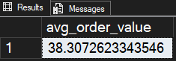
3. Total Pizza Sales:
select sum(quantity) as Total_Pizza_Sales
from pizza_sales;
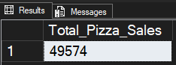
4. Total Order:
select count(distinct order_id) as Total_Order
from pizza_sales;
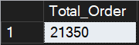
5. Avg Pizza Per Order:
select cast(cast(sum(quantity) as decimal(10,2))/cast(count(distinct order_id) as decimal(10,2)) as decimal(10,2)) as Avg_Pizza_Per_Order
from pizza_sales;
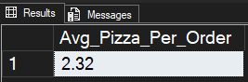
6.Daily Trend:
select datename(dw,order_date) order_day, count(distinct order_id) as Total_orders from pizza_sales group by datename(dw,order_date);
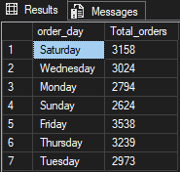
7. Hourly Trend:
select datepart(hour,order_time) order_hour, count(distinct order_id) as Total_orders
from pizza_sales
group by datepart(hour,order_time)
order by datepart(hour,order_time);
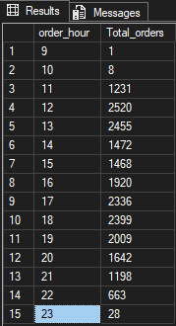
8.Sale Percentage per Category:
select pizza_category, sum(total_price) as total_sale,
sum(total_price)/(select sum(total_price) from pizza_sales)*100 as Sale_per_Category
from pizza_sales
group by pizza_category
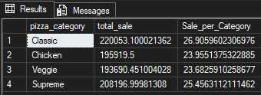
9.Sale per Size:
select pizza_size, sum(total_price) as total_sale,
sum(total_price)/(select sum(total_price) from pizza_sales)*100 as Sale_per_Size
from pizza_sales
group by pizza_size
order by Sale_per_Size desc;
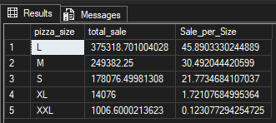

10.Total Pizza Sold:
select pizza_category, sum(quantity) as Total_Pizza_Sold
from pizza_sales
group by pizza_category;
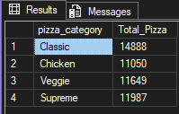

11.Top 5 Pizza Sold:

select top 5 pizza_name, sum(quantity) as Total_Pizza_Sold
from pizza_sales
group by pizza_name
order by Total_Pizza_Sold desc;
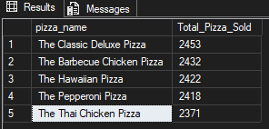

12.Worst 5 Pizza Sold:

select top 5 pizza_name, sum(quantity) as Total_Pizza_Sold
from pizza_sales
group by pizza_name
order by Total_Pizza_Sold asc;
